# ASSIGNMENT - 1

# Super Market Sales Analysis Visualization

**Name:** Suryapraba V

**NM ID:** au611220104159

**Step1:** Uploading the data

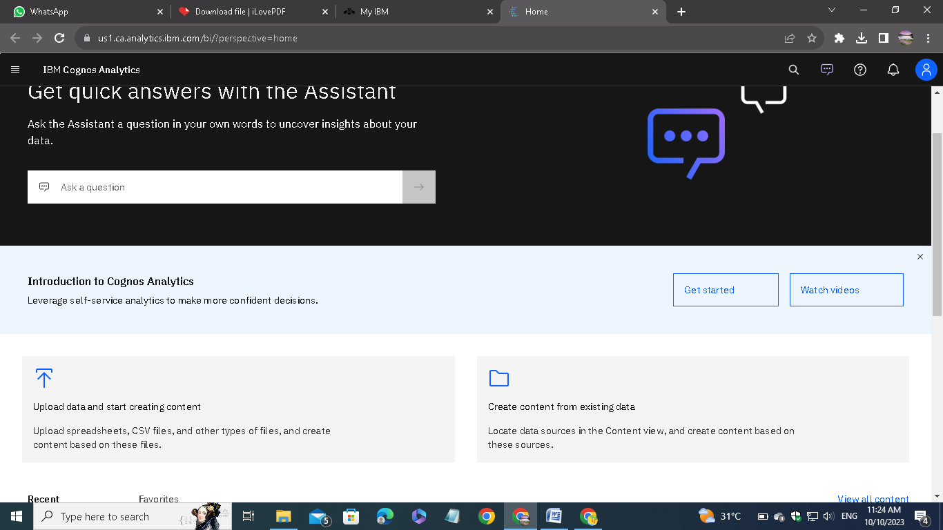

Open IBM Cognos Analytics. Then choose upload data.

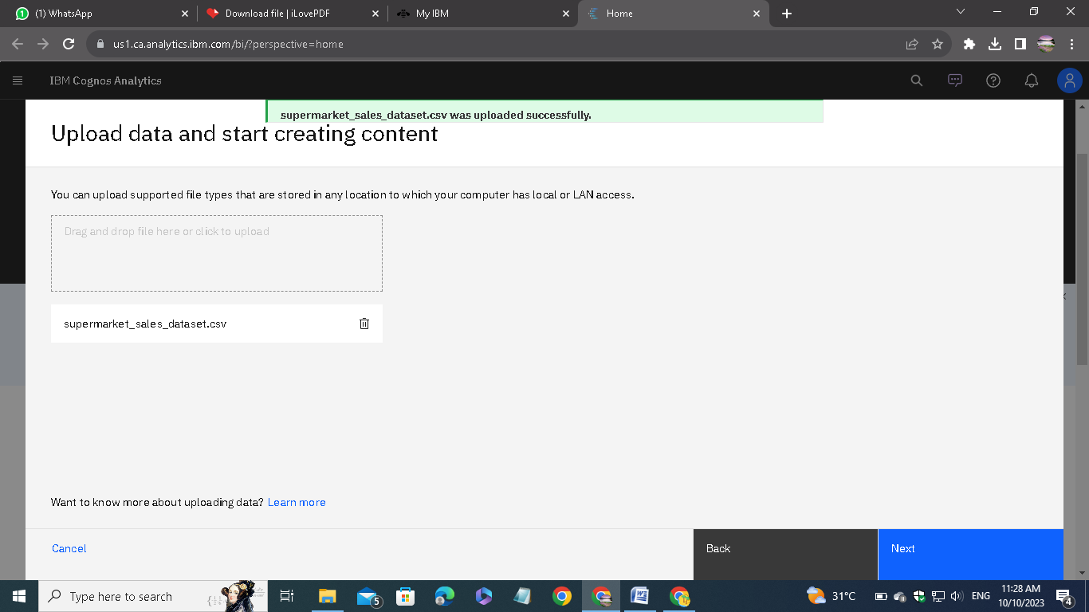

Upload the CSV data file which we downloaded from the given link on the assignment.

**Step3:** Explore the data

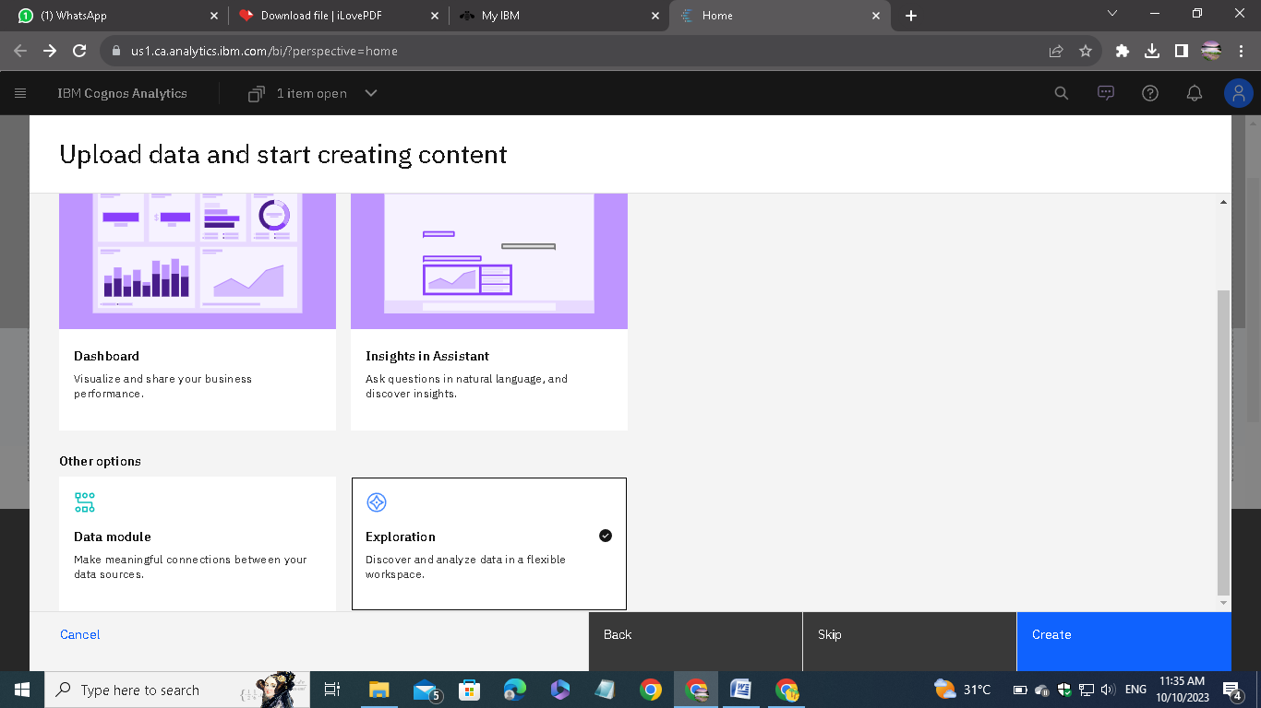

Go to exploration given in the menu and open the saved data module.

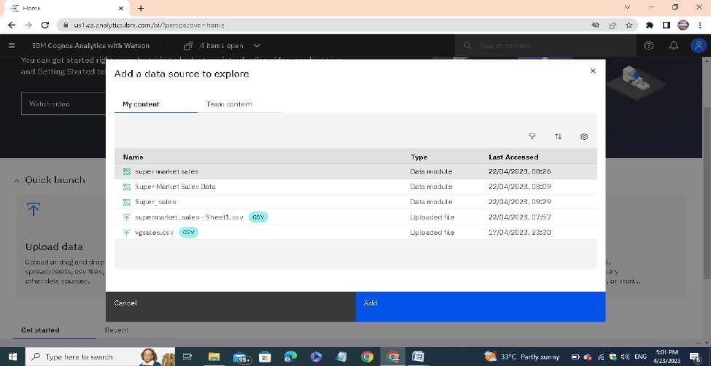

Then Select and add the data module that you want for the exploration.

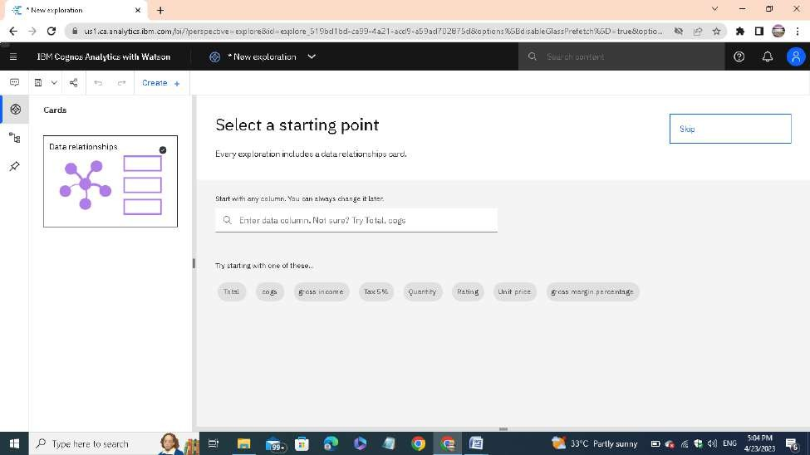

Click on create and select a card style. In my case, I have chosen the single visualization.

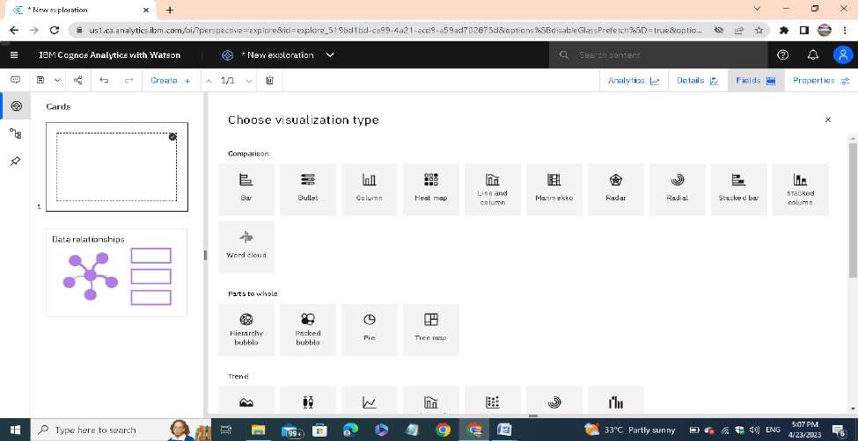

Then choose the type of the visualization. Each type of visualization is used for different requirements.

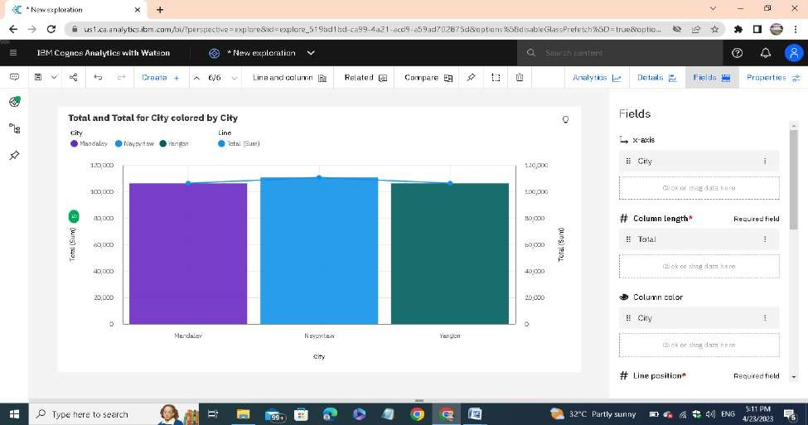

Create the chart using the type of visualization. In the fields, we have to mention the attributes for the x-axis, y-axis and colors.

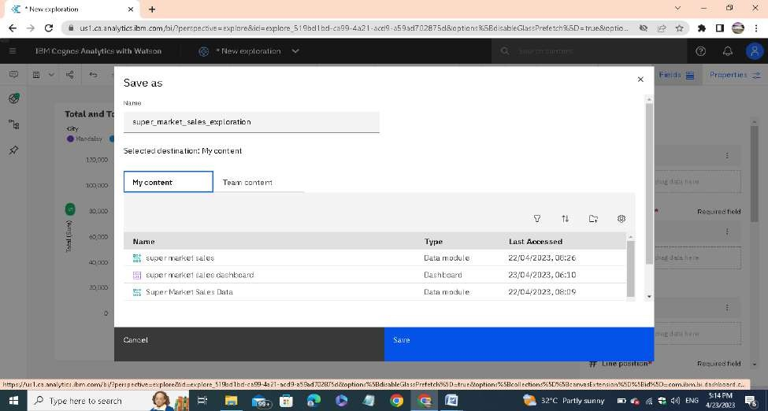

After exploring the data save it in a required name.

**Step4:** Presenting the data

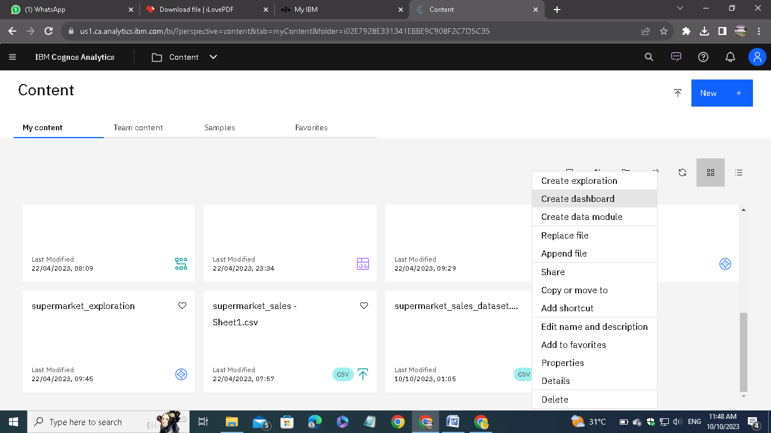

Go to the create dashboard option to visualize the explored dat

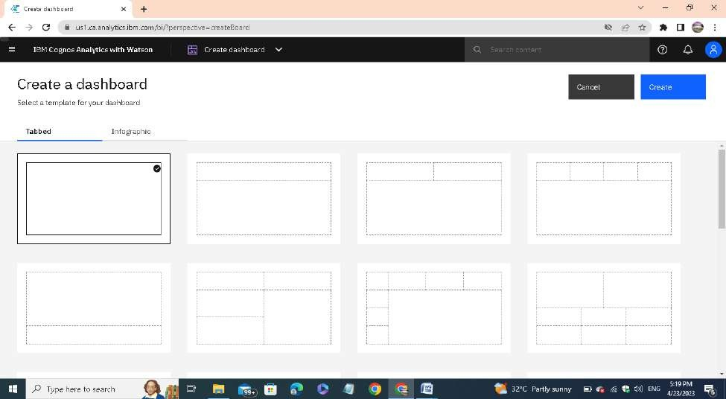

Select the type of dashboard.

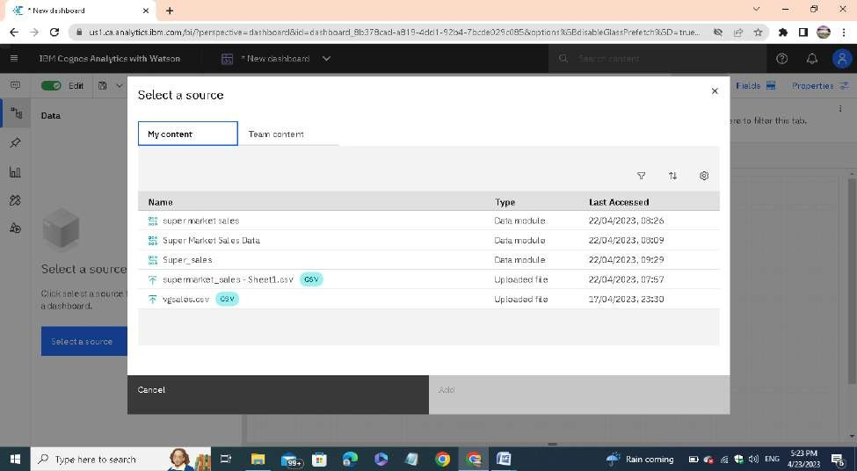

After selecting the type of dashboard click on “select a source ”button to add the source file to the dashboard.

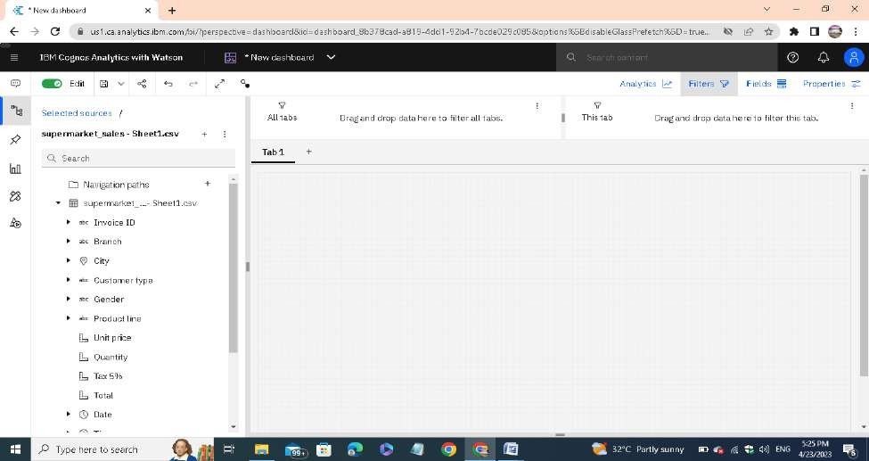

Adjust the dashboard settings for our convenience.

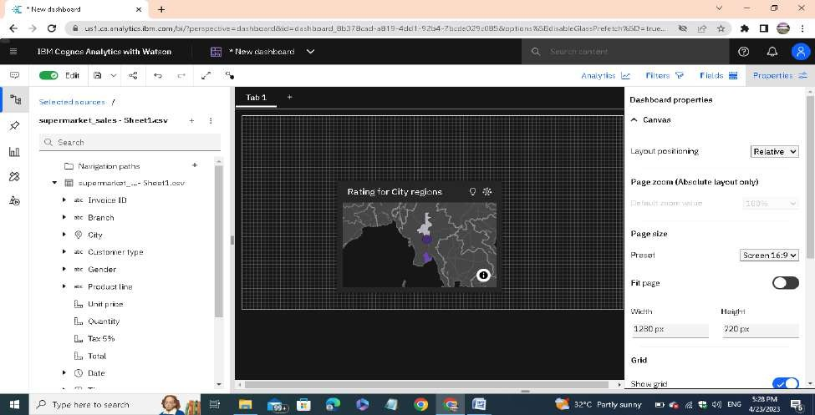

We can able to directly drag the data from the source or we can also able to plot our exploration directly from the pinned things.

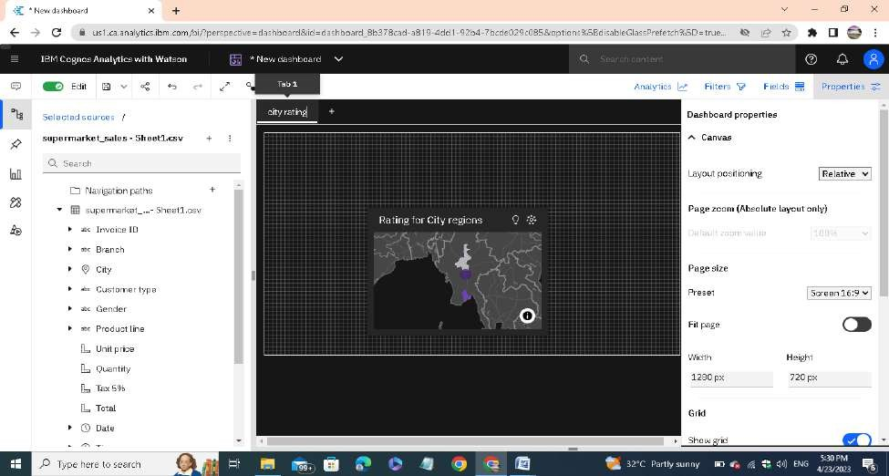

Double click on the tab name and change it for our reference.

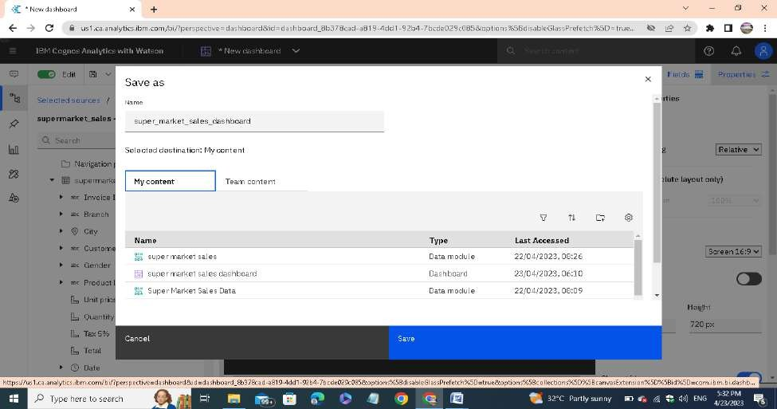e

After that save the presentation. These steps are followed for all other tabs. Finally we get the visualization of our analytics.

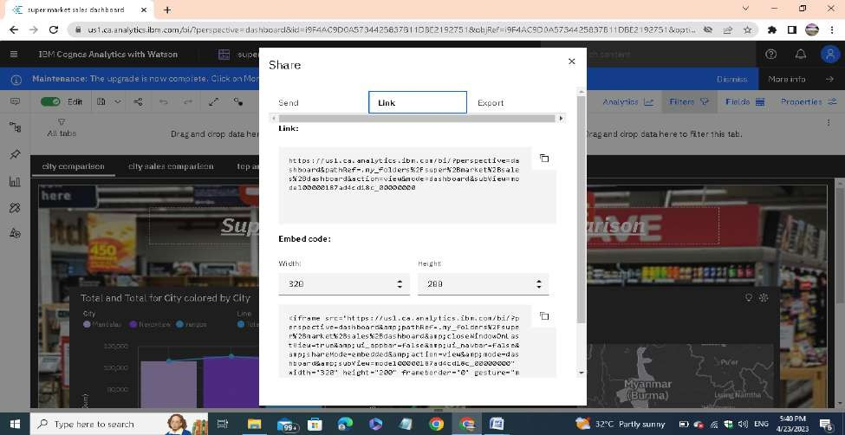

Using share option, we can able to share our presentation direct link or the embed code and through email too.

# Super Market Sales Analysis Visualization

Here I attached the screenshots of all the visualization tabs I created using supermarket sales data:

1. Super Market Sales City Wise Comparison

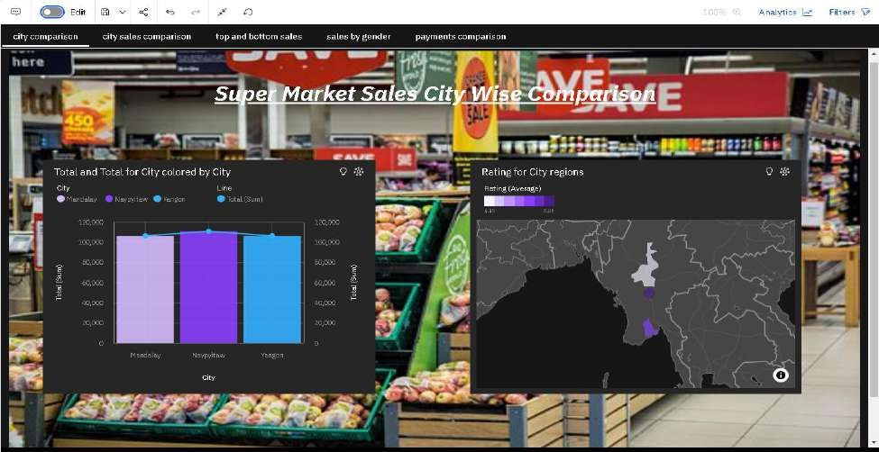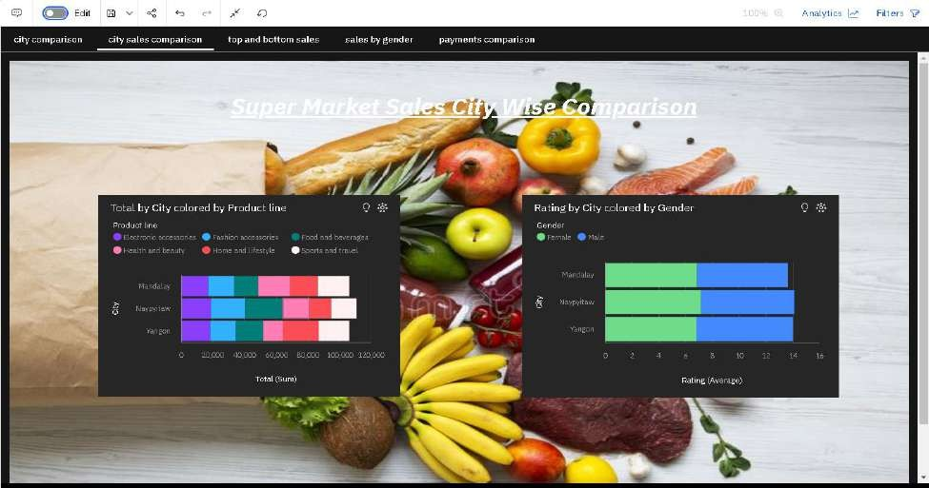

1. Super Market Sales Top 10 & Bottom 10

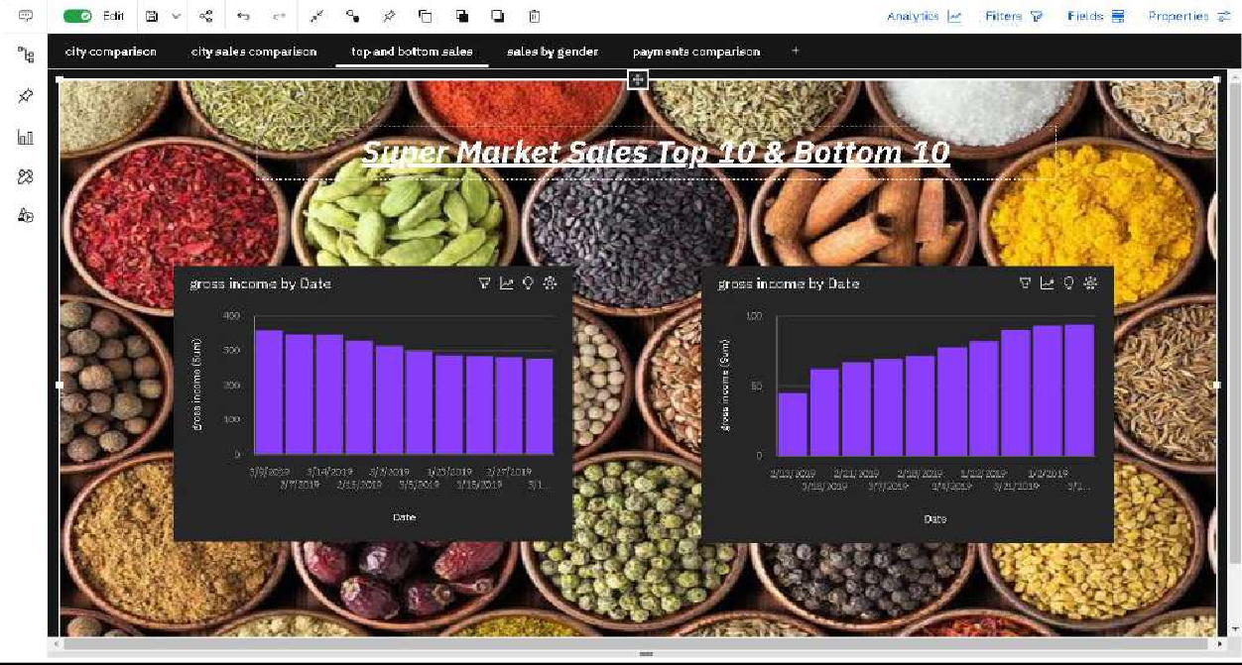

1. Super Market Sales Comparison By Gender

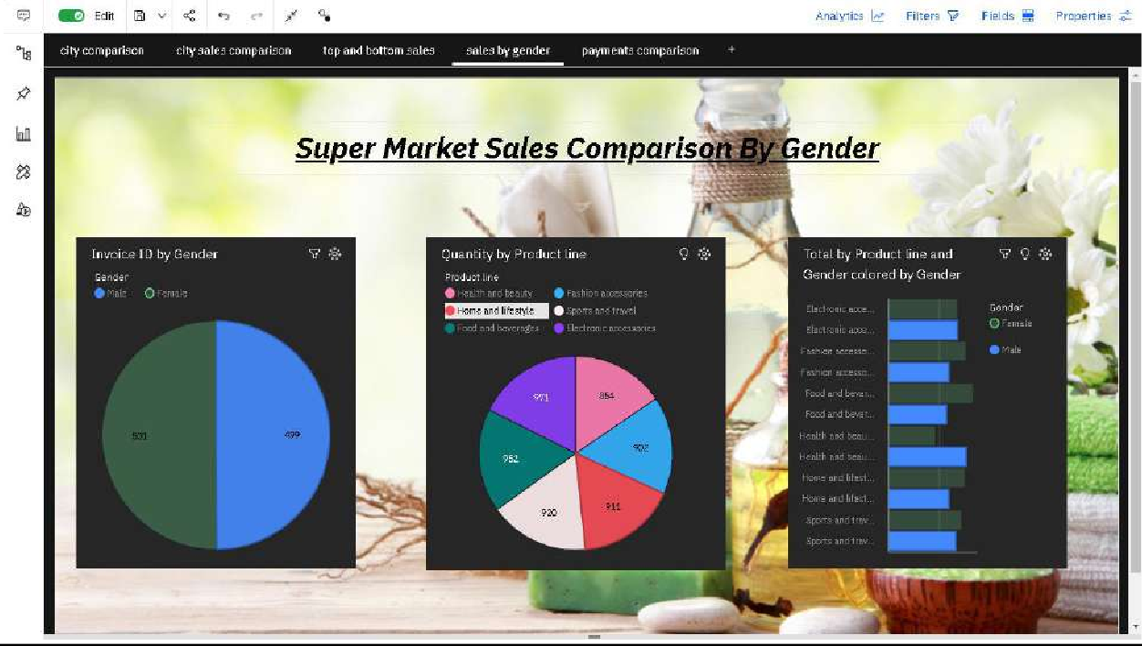

1. Super Market Sales Payment Comparison

